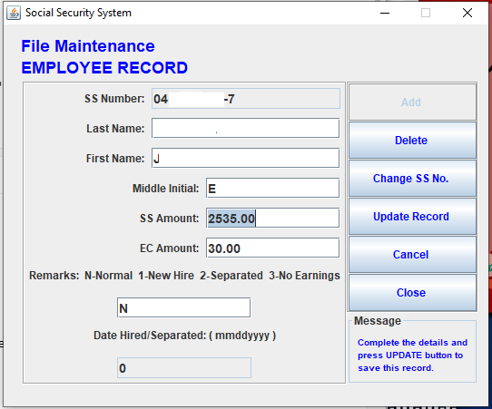

This is the basic screen of the R3 File Generator being used by the employers.

Scenario : Will not have separate field for MPF.

* Meaning the employer would have to manually add the SSS contribution and the MPF amount then encode it in the same field, which I might also say is misnamed.
* Wouldn’t it be more taxing for the encoder to do that and is more prone to error.

Solution :

* Would retain the same field and name, will add additional display for the MPF contribution corresponding to that SS amount. The system will add all the contributions, including the MPF and will be in the generated file.

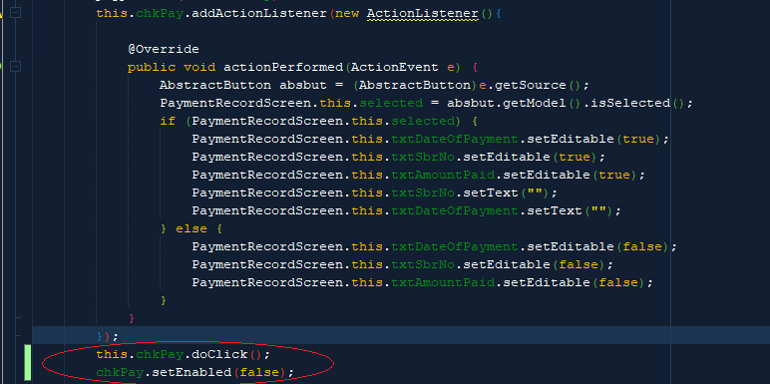

Added two lines to activate the checkbox for payment details. Creation of the SSS text file will not continue unless the payment details are filled. The same check box is disabled so it can not be unchecked.